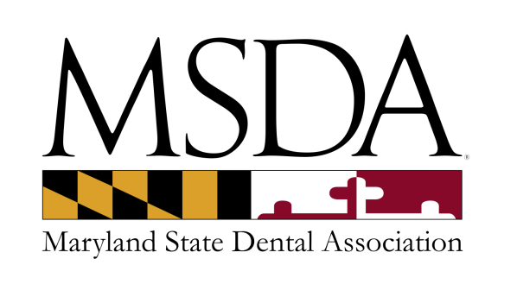

**ASSOCIATE MEMBERSHIP APPLICATION**

**Qualifications for membership:** Individual other than a dentist who is engaged in an area of activity related to dentistry and has a vested interest in the affairs of the Maryland State Dental Association. This is an **INDIVIDUAL membership**, not a company membership and you may not advertise your company as being a member of the MSDA in any way. The MSDA Board of Trustees shall approve or decline membership. **Registered dental hygienists and assistants qualify in this category**.

**Benefits:** Subscription to MSDA printed newsletter ⬩ listing in the printed MSDA Membership Directory under Associate Member ⬩ Member rates on advertising and courses

**Dues:** $175.00 per year

Checks should be payable to the MSDA & mailed to the address noted below along with this completed application.

We also accept VISA/MASTERCARD/DISCOVER/AMEX.

Credit card number: ___________________________________________________________________

Expiration date: ________________________ CVV Code: _____________________________________

Name: ______________________________________________________________________________

Business Name (if applicable): ___________________________________________________________

Business Address: _____________________________________________________________________

____________________________________________________________________________________

Office Phone: ____________________________ Fax: _________________________________________

Email address: ________________________________________________________________________

Website: _____________________________________________________________________________

Signature: _________________________________________ Date: _____________________________

**Return to: MSDA via Fax: (410) 964-0583 or membership@msda.com   
Questions, contact MSDA Membership at (410) 964-2880.  
MSDA 8901A Herrmann Drive ⬩ Columbia, MD 21045**